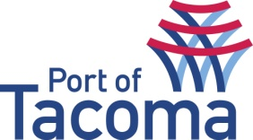
SUBMITTAL LIST
RFQ | 071717 On-Call Estimating Constructability & Project Management Support Services (2022)
CONTACT | Jerry Clardy, Sr. Contracts Administrator
EMAIL | procurement@portoftacoma.com
PHONE NUMBER | 253-888-4751
PROPOSAL DUE DATE | September 1, 2022, 2:00 PM @ 2:00 PM (PST)
Solicitation Status’s: Submitted – Short List – Interview – Awarded – Non-responsive (NR)
VENDOR NAME |  | STATUS
ELLE Consultants |  | Submitted

