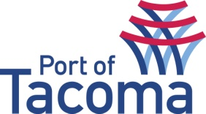
SUBMITTAL LIST
RFQ/ TITLE | 070345 | Video Production & Webstreaming
CONTACT | Heather Shadko, Procurement
EMAIL | procurement@portoftacoma.com
PHONE NUMBER | 253-428-8697
PROPOSAL DUE DATE | June 8, 2016 @ 2:00 PM (PST)
Solicitation Status’s: Submitted – Short List – Interview – Negotiations – Award
VENDOR NAME | STATUS
Seattle Colleges Cable Television (SCCtv) | Submitted
Worktank Enterprises, LLC | Submitted

