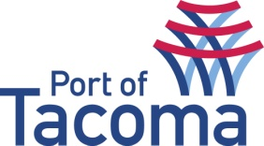
SUBMITTAL LIST
RFQ/ TITLE | 070344 | Consultant Services for Deferred Compensation Plan
CONTACT | Heather Shadko, Procurement
EMAIL | procurement@portoftacoma.com
PHONE NUMBER | 253-428-8697
PROPOSAL DUE DATE | June 6, 2016 @ 2:00 PM (PST)
Solicitation Status’s: Submitted – Short List – Interview – Negotiations – Award
VENDOR NAME | STATUS
Hyas Group | Submitted – Short List

