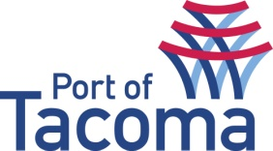
SUBMITTAL LIST REVISION #03
RFQ/ TITLE | 070329 | Water Quality Program On-Call Services
CONTACT | Sherry Arciniega, Procurement
EMAIL | procurement@portoftacoma.com
PHONE NUMBER | 253-383-9458
PROPOSAL DUE DATE | May 18, 2016 @ 2:00 PM (PST)
Solicitation Status’s: Submitted – Short List – Interview – Negotiations – Award
VENDOR NAME | STATUS
CATEGORY A:
EA Engineering, Science & Technology | Submitted
Farallon Consulting, LLC | Submitted
Floyd Snider | Submitted
Kennedy Jenks | Submitted – Short List
Marx Environmental | Submitted – Short List – Interview
Maul Foster & Alongi | Submitted
Ramboll Environ | Submitted
CATEGORY B:
Cocker Fennessy, Inc (Kennedy Jenks) | Submitted – Short List
EA Engineering, Science & Technology | Submitted
ERM-West, Inc. | Submitted
Floyd Snider | Submitted – Short List
GeoEngineers, Inc. | Submitted
Ramboll Environ | Submitted
CATEGORY C:
EA Engineering, Science & Technology | Submitted
Kennedy Jenks | Submitted – Short List – Interview
Parametrix | Submitted – Short List – Interview
Ramboll Environ | Submitted

