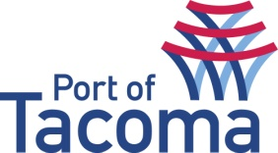
SUBMITTAL LIST
06/08/2015
 | RFQ 070093 | Portac Site Investigation
CONTACT | Jana Prince, Procurement
EMAIL | procurement@portoftacoma.com
PHONE NUMBER | 253-830-5330
PROPOSAL DUE DATE | May 21, 2015 @ 3:00 PM (PST)
SOLICITATION STATUS | Submitted – Short List – Interview
VENDOR NAME | STATUS
Amec Foster Wheeler | Submitted – Shortlisted
Environmental Partners, Inc. | Submitted
Environmental Resources Management | Submitted
Floyd Snider | Submitted
GeoEngineers | Submitted
GSI | Submitted – Shortlisted
Innovex Environmental Management | Submitted
Landau Associates | Submitted
Maul Foster Alongi | Submitted
Northgate Environmental Management | Submitted
Pacific Groundwater Group | Submitted
Windward Environmental, LLC | Submitted

